**Jessie George**

HW1

**1 a**

y = -f(Y/Z) = -50(12000/95000) = -6.32mm

6.32mm = 0.25 inches

Number of pixels = 300 * 0.25 = 74.5 = 75 pixels

**Answer: The height of the image is 6.32mm and there are 75 pixels.**

**1 b**

Number of pixels = 640x480

RGB means 3 color channels

Using 8 bits per color channel, total number of bytes = 3*8*640*480 = **7,372,800 bytes**

Using 10 bits per color channel, total number of bytes = 3*10*640*480 = **9,216,000 bytes**

Using 12 bits per color channel, total number of bytes = 3*12*640*480 = **11,059,200 bytes**

Using 14 bits per color channel, total number of bytes = 3*14*640*480 = **12,902,400 bytes**

**2**

Output voltage = ADC reading * (R/(2^b) )

ADC reading = B3 in hex = converting to decimal, (11*(16^1)) + (3*(16^0)) = 179 in decimal

Range R = 6 - 2 = 4 Volts

b = 8 bytes

2^b = 256

Output voltage = 179 * (4/256) = **2.80 Volts**

Using 8 bit ADC, Quantization error = R/ (2^b) = 4/(2^8) = **0.0156**

Using 12 bit ADC, Quantization error = 4/(2^12) = 0.000977

Percent change in error = ((0.000977 – 0.0156)/0.0156)*100 = -93.7%  
If we approximate with 12 bits instead of 8 bits, the **error reduces by 93.7%**

**3**

Bit rate for speech signal = 12 * 20 because it’s sampled at 20kHz

= **240kbps**

Bit rate for music signal = 16*40 because it’s sampled at 40kHz

= **640kbps**

Stereophonic music comes from at least 2 channels so storage needed is

= 2 * (10*60)seconds * 640K samples per sec

= 76800 kbits

= 9600 kbytes

= **96 megabytes**

**4**

Human hearing range is up to 20kHz so sampling rate for CD must be at least twice the highest frequency (2*20kHz = 40 kHz), with room for error in interpolation so it is 44.1kHz. Since a CD can contain sounds other than human speech, like music, it needs the full range.

Intelligible speech requires up to 4kHz, therefore the Nyquist rate for reliable speech communication = 2* 4kHZ = **8kHz**

People sound different on the phone because certain frequencies of the voice will be lost or modified due to sample rate and bit rate.

Maximum bit rate for telephone = 8k samples per sec * 7 bits per sample = **56kbps**

Bit rate for CD = 44.1k samples per sec * 16 bits per sample = **705.6kbps**

Modem connection cannot support streamed CD quality audio because bit rate for modem is much lower than bit rate for CD.

**(SEE NEXT PAGES FOR QUESTION 5)**

**5 – Image 1 for chromatic aberration**

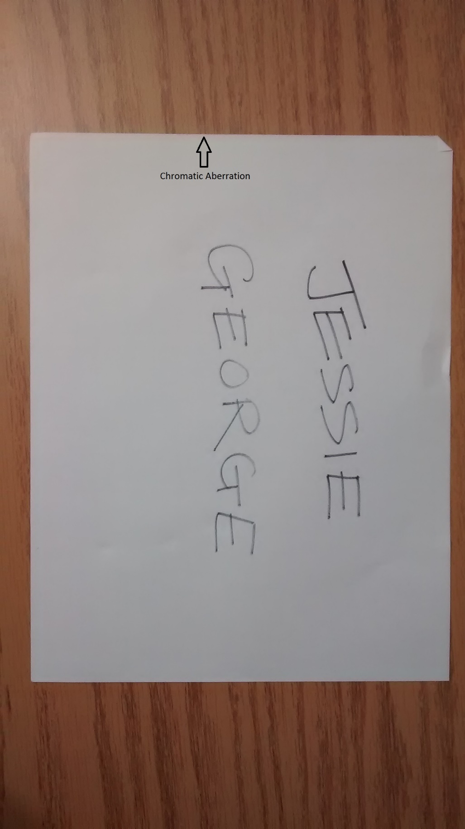

**5 – Image 2 for Geometric Aberration**



**(SEE NEXT PAGE FOR QUESTION 6)**

**6**

1. In 2015, the total number of videos on Youku Tudou reached 4000 according to <http://expandedramblings.com/index.php/business-directory/20010/youku-tudou/>
2. In 2015, the total number of videos on MySpace reached 53 million according to <http://expandedramblings.com/index.php/myspace-stats-then-now/2/>
3. In 2015, 8,102 images were uploaded per second to Whatsapp according to <http://www.adweek.com/socialtimes/how-many-photos-are-uploaded-to-snapchat-every-second/621488>
4. In 2016, the total number of videos uploaded to Vine reached 39 million according to <http://expandedramblings.com/index.php/vine-statistics/>
5. In 2016, the total number of videos on Vevo reached 140,000 according to <http://www.vevo.com/c/EN/US/about>
6. In 2014, the total number of images on Jeevansathi.com was approximately 850,000 according to <http://www.wlivenews.com/top-15-best-leading-and-popular-matrimonial-websites-in-india.html>
7. In 2012, the total number of videos on Khan Academy reached 4560 according to [http://whatbadgenext.appspot.com/total_topic_times](http://whatbadgenext.appspot.com/total_topic_times%20)
8. In 2016, the total number of videos on Hulu crossed over 118,500 according to <https://www.youtube.com/watch?v=CJtPn3fjA5c>
9. In 2015, 8,796 images were uploaded per second to Snapchat according to <http://www.adweek.com/socialtimes/how-many-photos-are-uploaded-to-snapchat-every-second/621488>
10. In 2011, the total number of images on Flickr reached 6 billion according to <http://latimesblogs.latimes.com/technology/2011/08/flickr-reaches-6-billion-photos-uploaded.html>
11. In 2016, 300 million images were uploaded per day to Facebook according to <https://zephoria.com/top-15-valuable-facebook-statistics/>
12. In 2016, 300 hours of videos are uploaded per minute to YouTube according to <https://www.brandwatch.com/2016/03/96-amazing-social-media-statistics-and-facts-for-2016/>
13. In 2016, over 80 million images are uploaded per day to Instagram according to <https://www.brandwatch.com/2016/03/96-amazing-social-media-statistics-and-facts-for-2016/>